Everything is similar in RF as of DT, there are only few differences:

**n_estimators:** how many base learners or DT to be used.

**n_jobs:** if it’s set to -1, it automatically finds the processors available and then use them for parallel execution.

**Oob_score:** if it’s true then it return the oob score too.

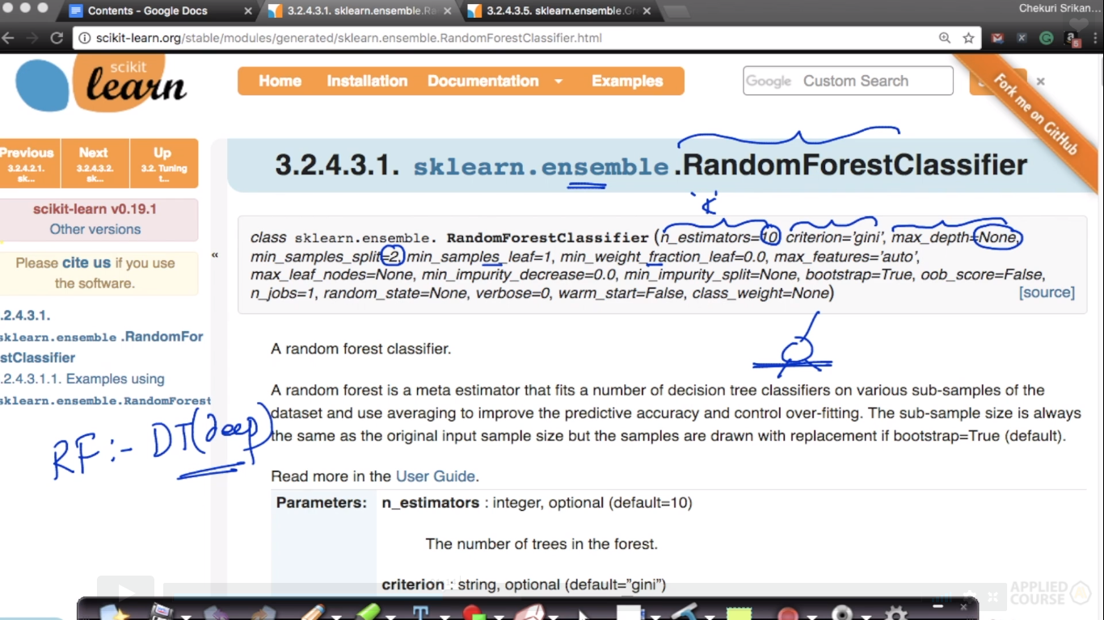

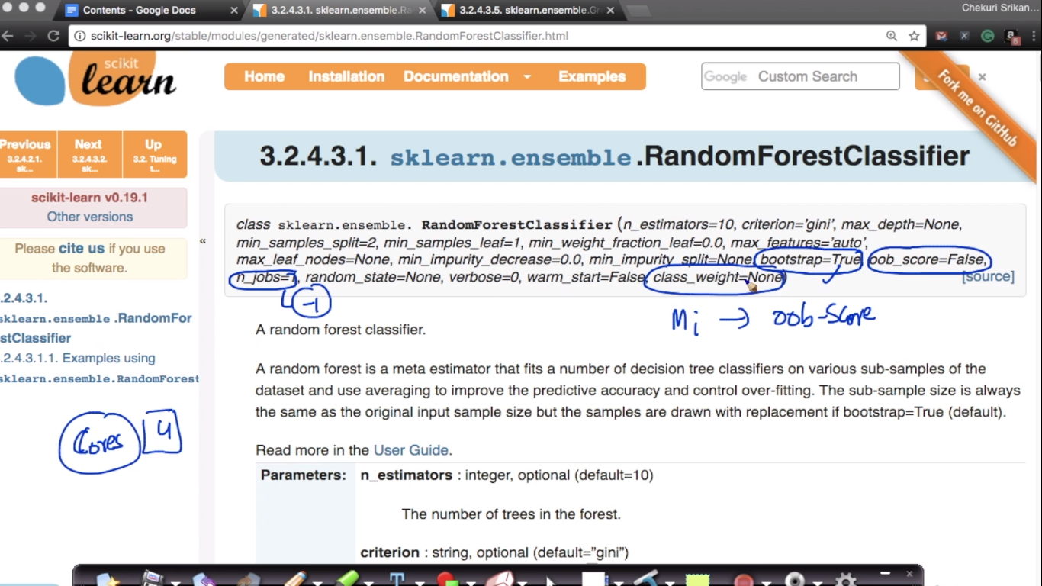

Feature selection

<https://chrisalbon.com/machine_learning/trees_and_forests/feature_selection_using_random_forest/>

